# Prerequisite-Setting Up the correct folder structure

SnapshotSerengetiS05.json.zip was downloaded from <http://lila.science/datasets/snapshot-serengeti>

ret_images.py was downloaded from <https://github.com/kawidman3/seis_ai_final>

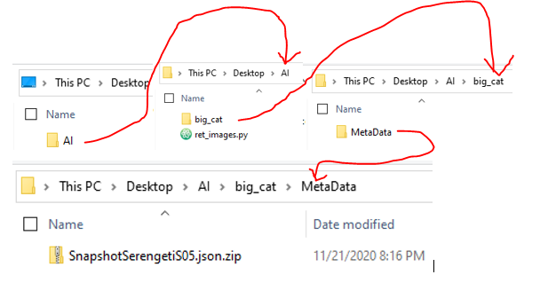

# Extracting & Uploading Impala Images (Season5) onto Google Drive

1.Run Anaconda Prompt as the administrator and within the console type “python” first in order to verify that python is installed and second type “exit()” in order to exit the console

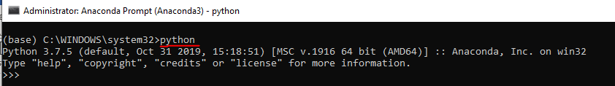

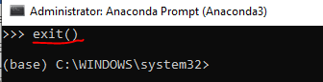

2.Within Anaconda Prompt change directories to point to the project folder called “AI” . Furthermore, use pip to install packages (wget [retrives data from webservers] and tqdm)

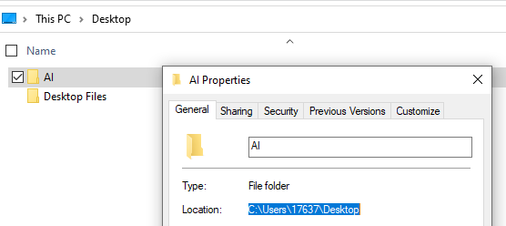 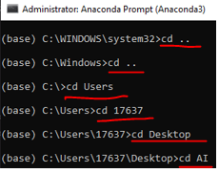

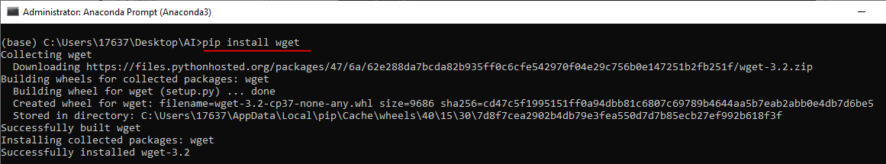

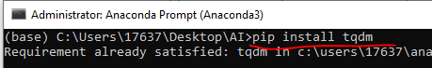

3.Open “ret_images.py” using Notepad++, change the zipped json file names & the file path for the stored zip json file then uncomment all the method calls in the main method

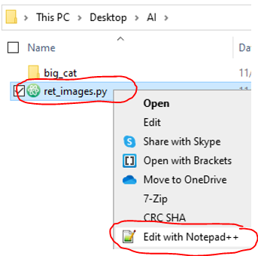

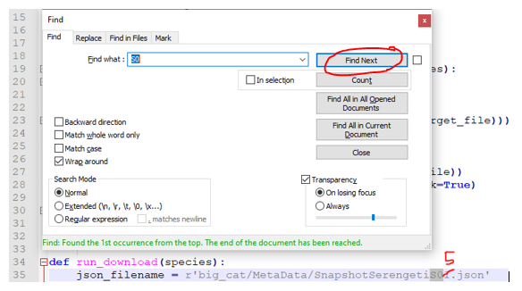

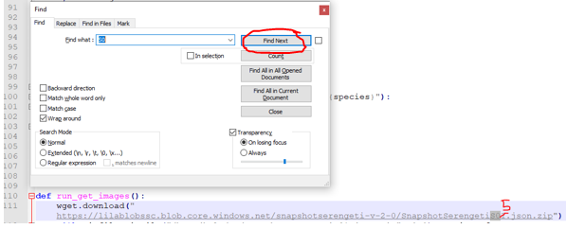

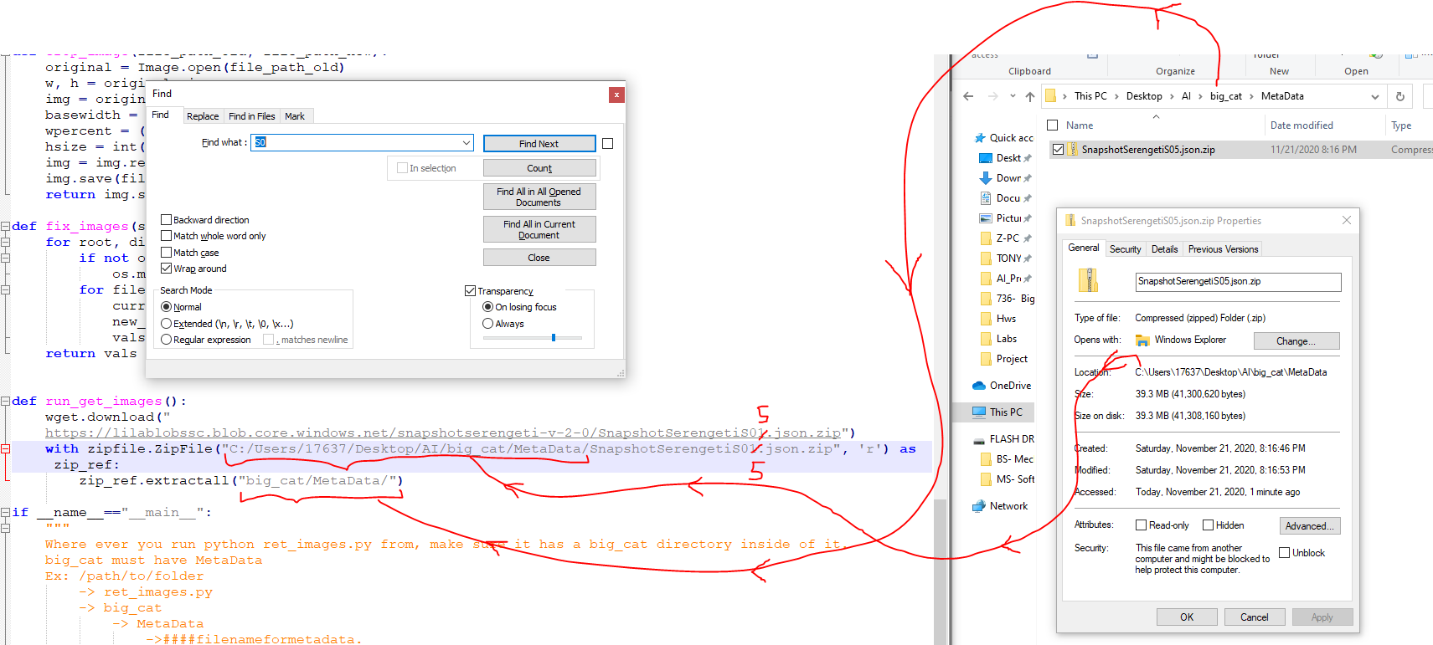

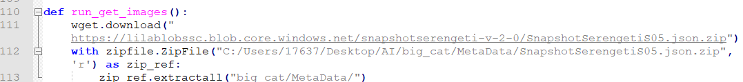



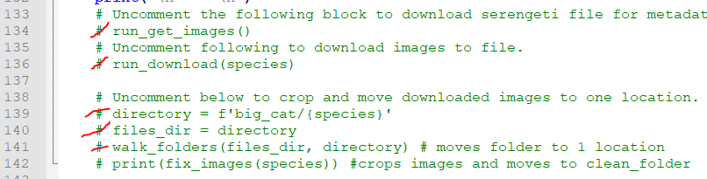

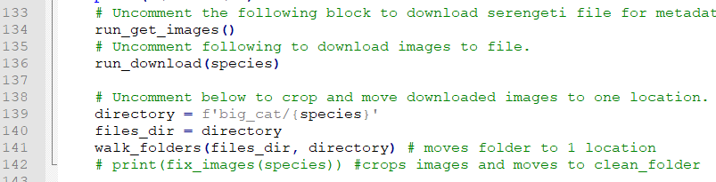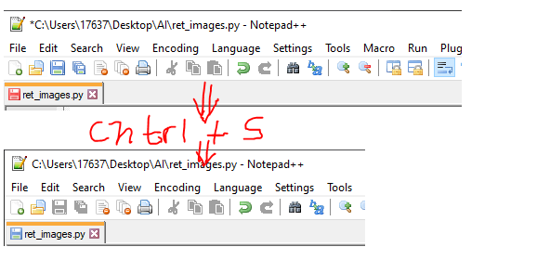

4.Within Anaconda Prompt while the current working directory is pointing to the project folder called “AI” . We type in “python ret_images.py” in order to run the python code for extracting all the impala images from Season 5.

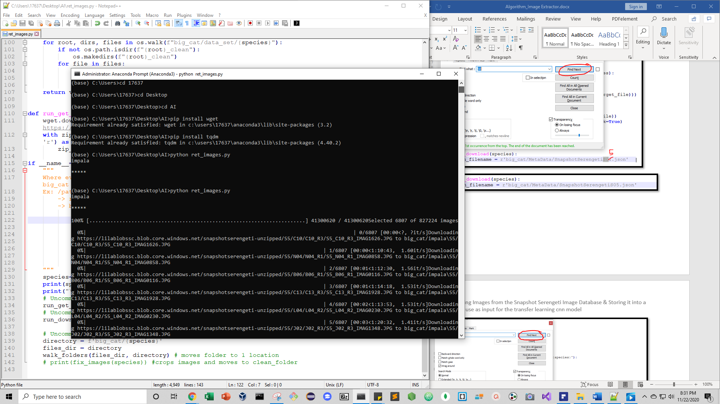

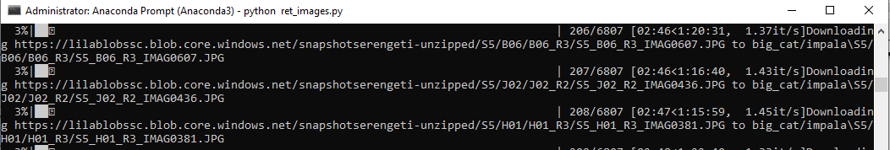

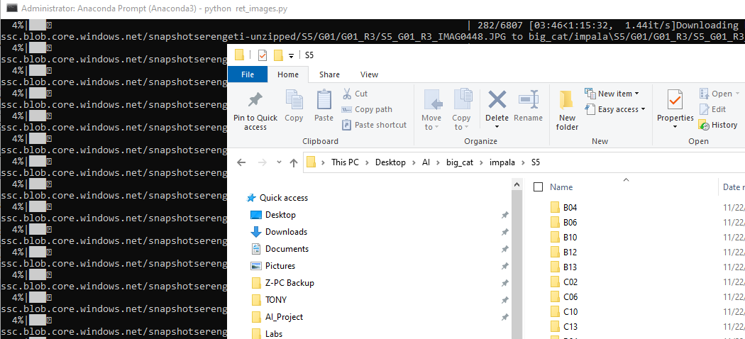

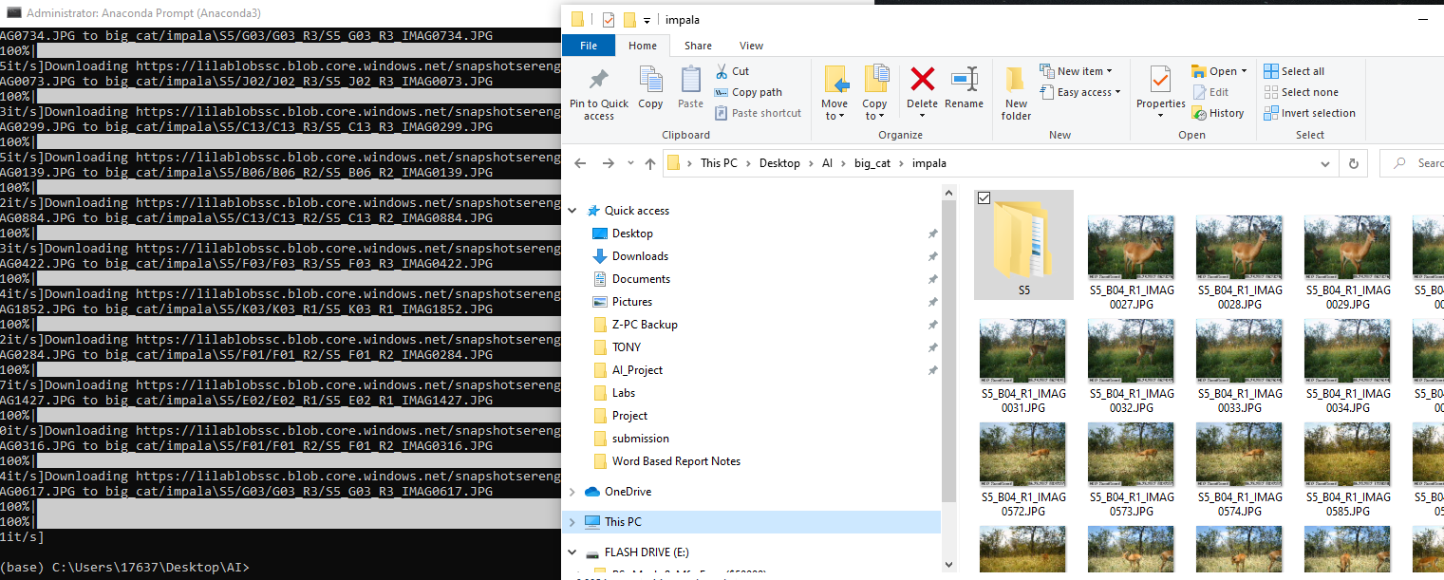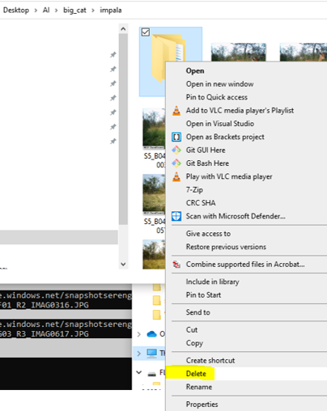

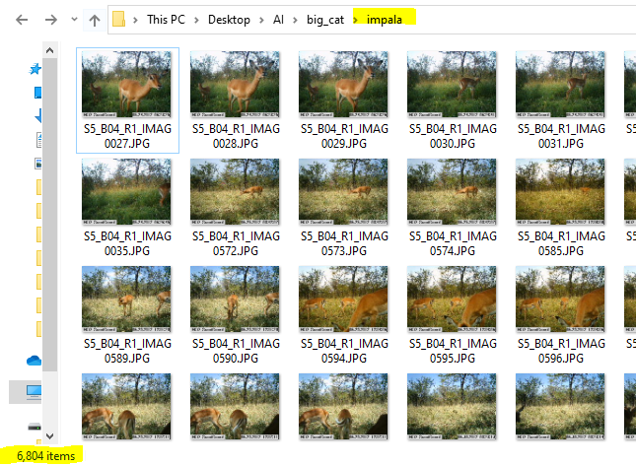

5.Manually pick 200 good images out of the 6804 images from the impala folder, delete the rest of the images and re-save the impala folder.

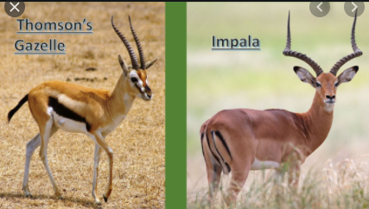

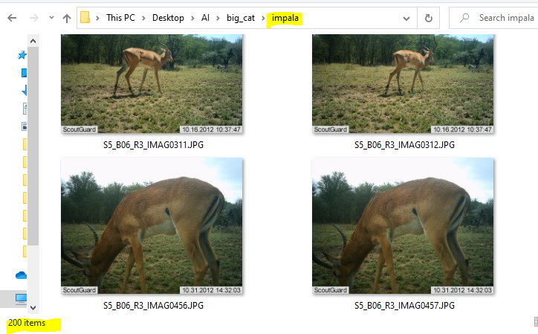

6. Comments everything in the main method of “ret_images.py” (except for line # 142) & return the python script by typing “python ret_images.py” in the Anaconda Prompt which resizes and crops all the images from “impala” and saves it in a new folder called “impala_clean”

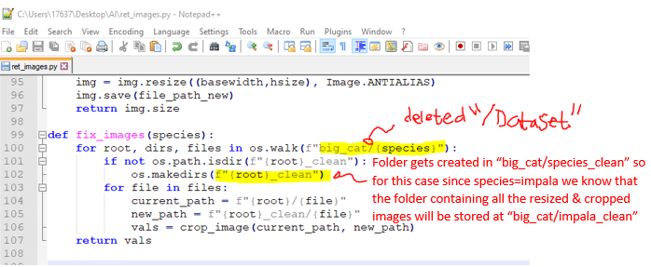

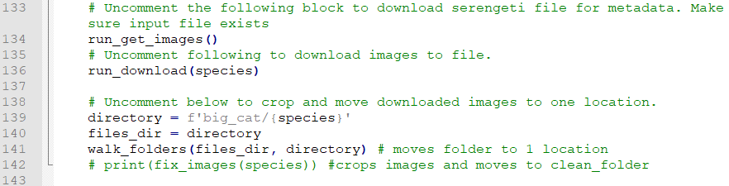

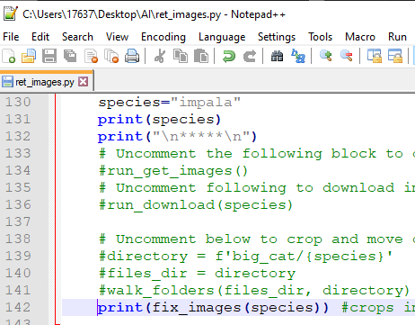

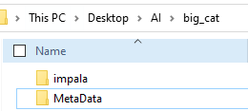

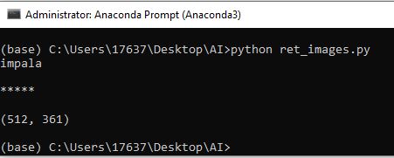

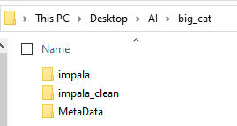

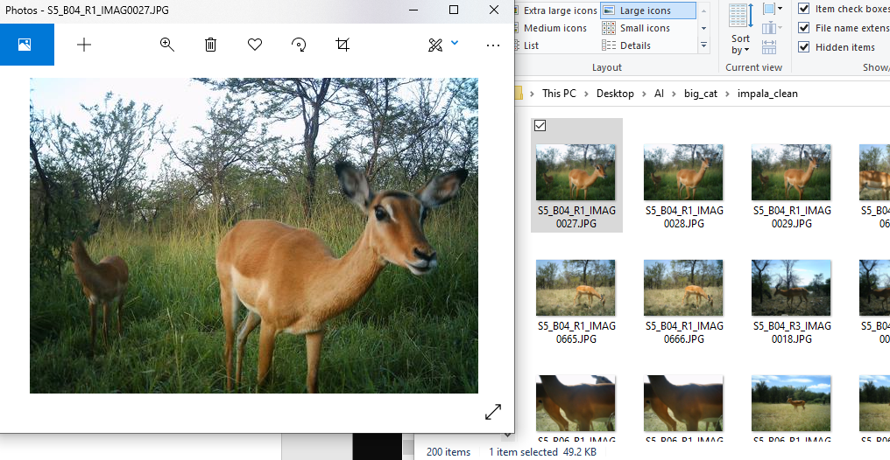

7.Uploading the clean data folder “impala_clean” into the project folder stored on google drive

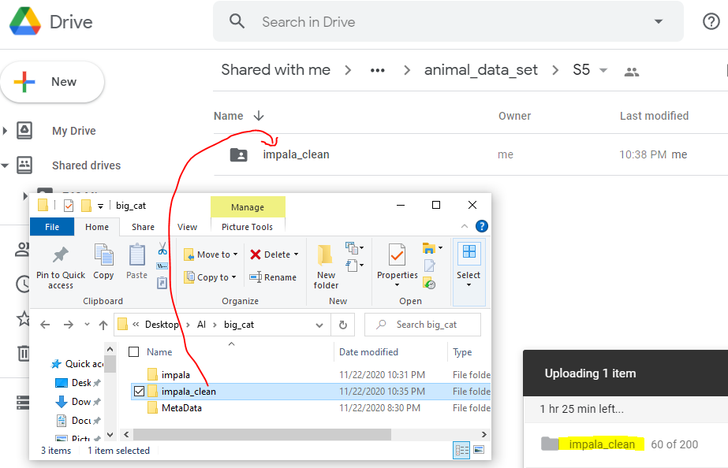

# Extracting & Uploading Elephant Images (Season5) onto Google Drive

1.Updating & rerunning the python script to download elephant images from season 5.

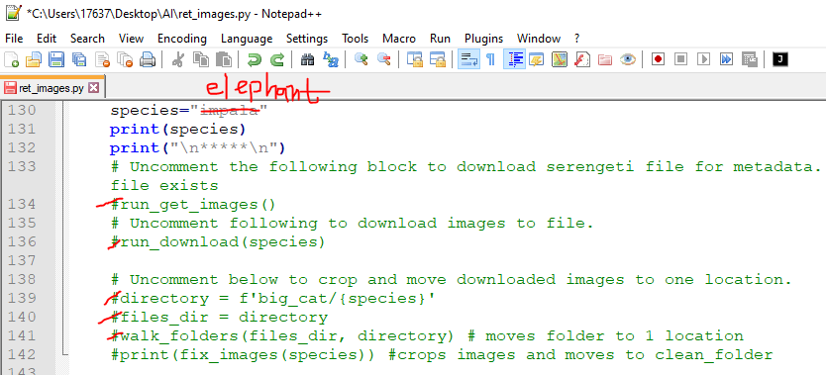

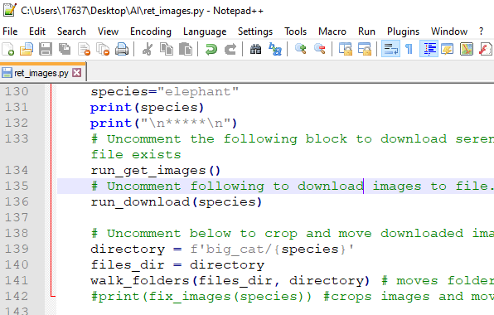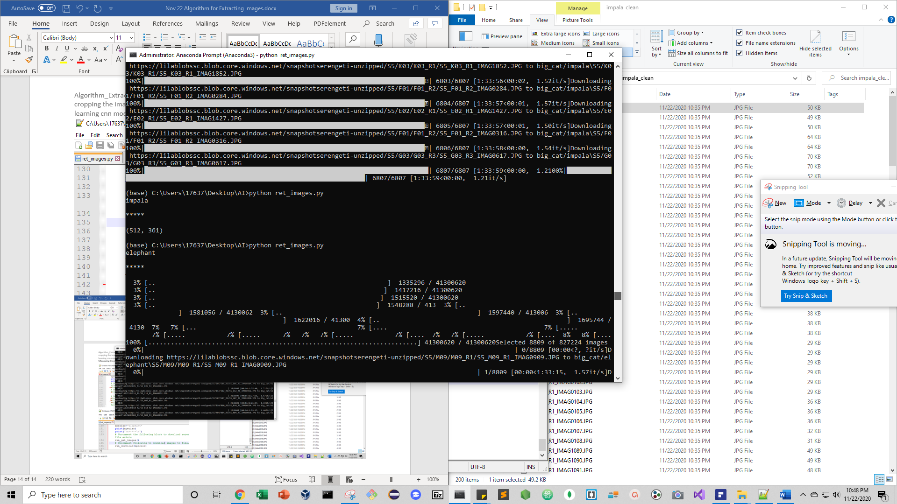

2.Manually pick 200 good images out of the 8809 images from the elephant folder, delete the rest of the images and re-save the elephant folder.

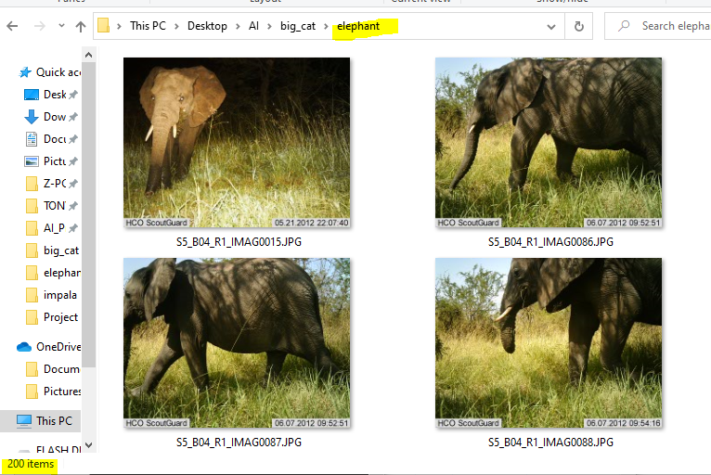

3. Comments everything in the main method of “ret_images.py” (except for line # 142) & return the python script by typing “python ret_images.py” in the Anaconda Prompt which resizes and crops all the images from “elephant” and saves it in a new folder called “elephant_clean”

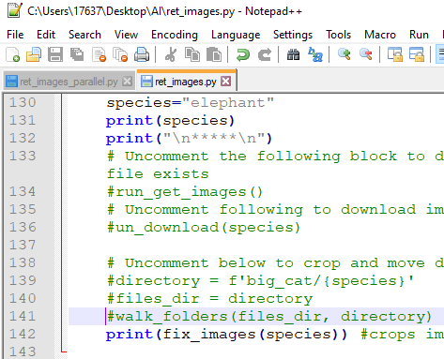

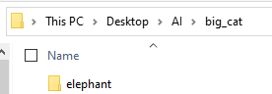

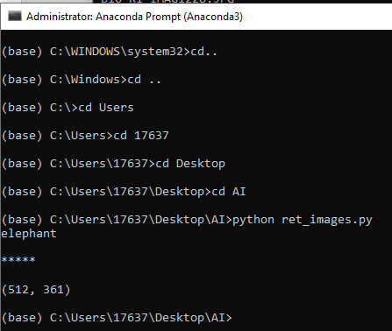

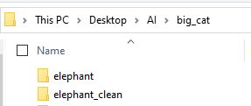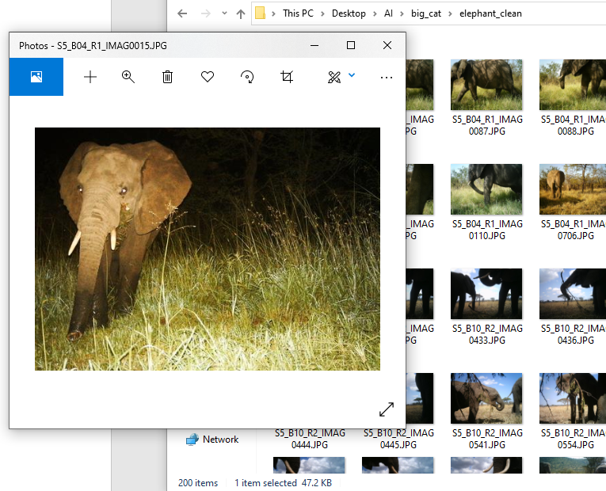

4.Uploading the clean data folder “elephant_clean” into the project folder stored on google drive

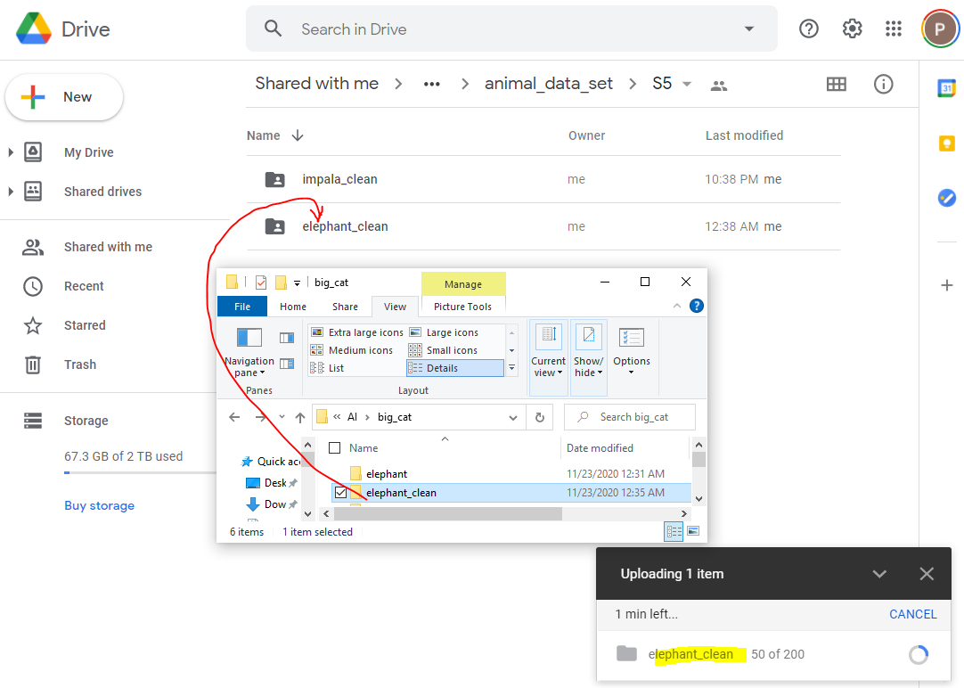

# Extracting & Uploading Zebra Images(Season5) onto Google Drive

1.Updating & rerunning the python script to download zebra images from season 5.

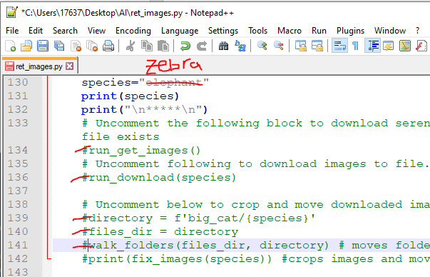

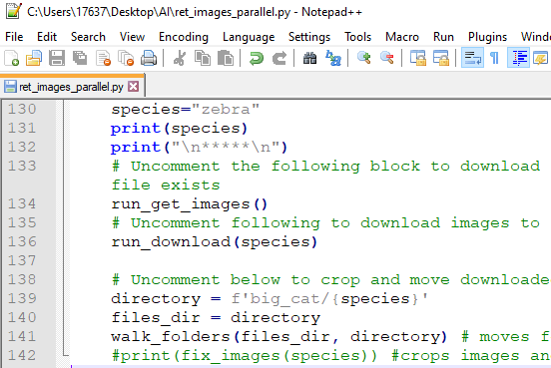

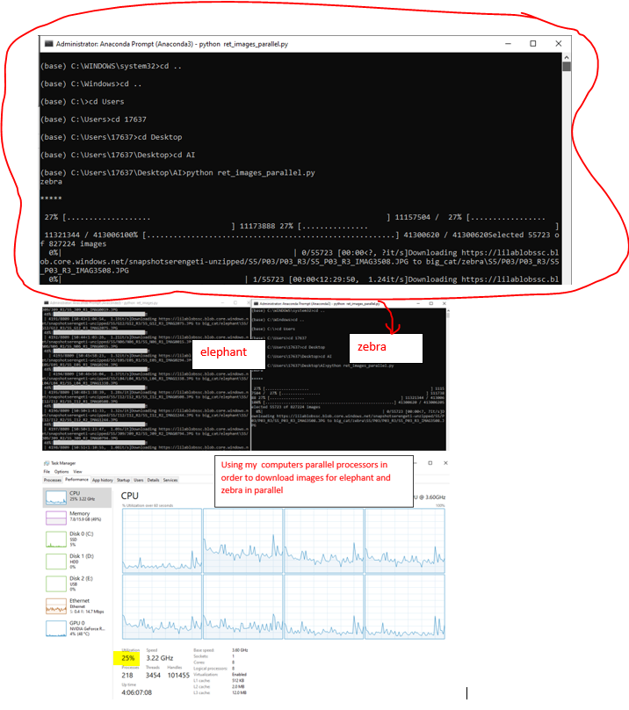

2.Manually pick 200 good images out of the 55723 images from the zebra folder, delete the rest of the images and re-save the zebra folder.

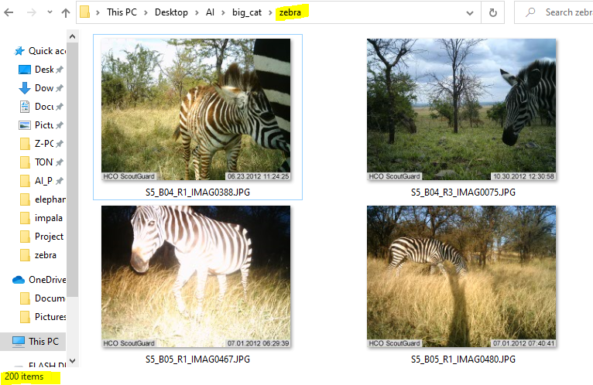

3. Comments everything in the main method of “ret_images.py” (except for line # 142) & return the python script by typing “python ret_images.py” in the Anaconda Prompt which resizes and crops all the images from “zebra” and saves it in a new folder called “zebra_clean”

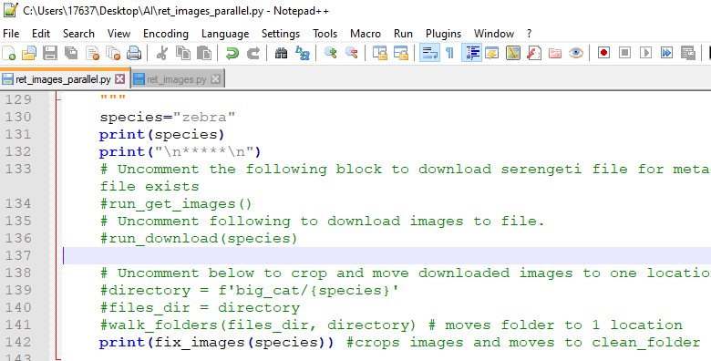

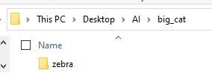

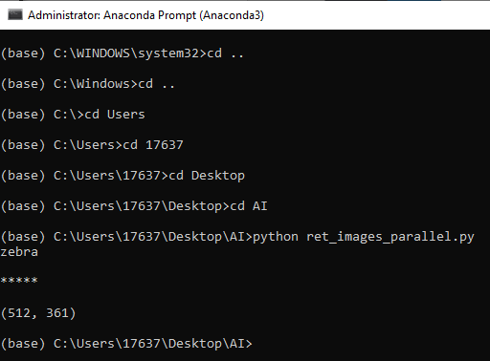

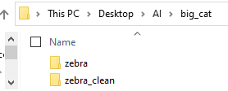

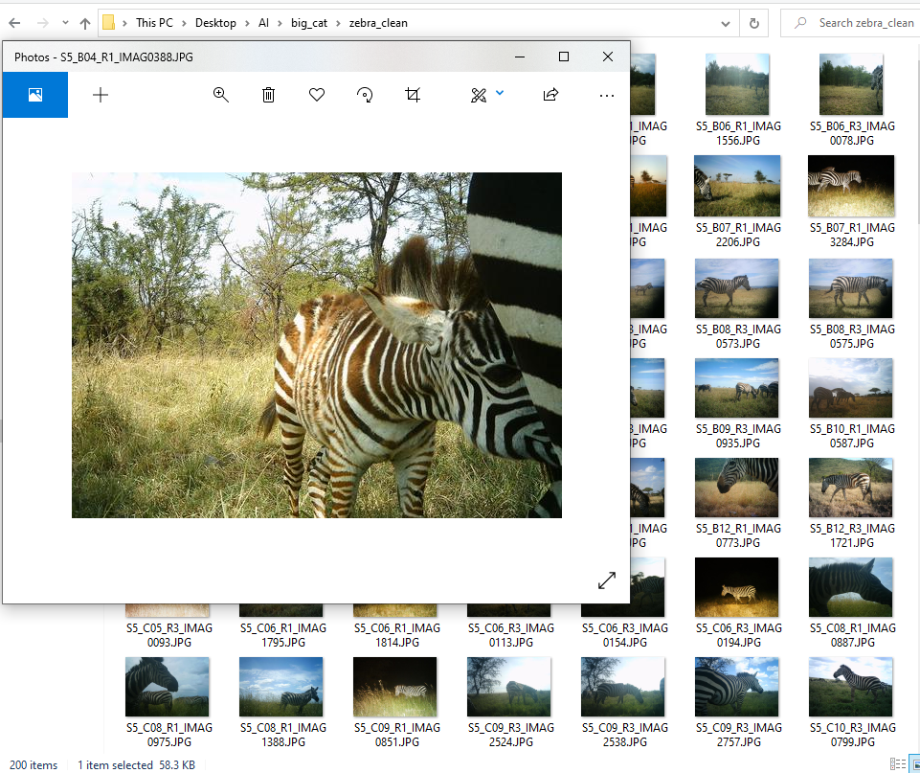

4.Uploading the clean data folder “zebra_clean” into the project folder stored on google drive

